IS DOCUMENT INCLUDING, DRAWINGS, PROCEDURES, SPECIFICATIONS, AND ITS CONTENTS IS THE EXCLUSIVE PROPERTY OF MODEC AND IS FURNISHED ON A CONFIDENTIAL BASIS, AND WITH THE EXPRESS AGREEMENT THAT IT WILL NEITHER BE USED, SOLD, TRANSFERRED, COPIED, TRACED, PHOTOGRAPHED, NOR REPRODUCED IN ANY MANNER WHATSOEVER IN WHOLE OR IN PART, NOR ANY ITEM HEREIN BE SOLD, MANUFACTURED OR ASSEMBLED WITHOUT THE WRITTEN AGREEMENT OF MODEC THE RECIPIENT OF THIS DOCUMENT AGREES NOT TO DISCLOSE TO ANY OTHER PARTY INFORMATION CONTAINED HEREIN, OR NOT TO USE SUCH INFORMATION, EXCEPT FOR THE SPECIFIC PURPOSE INTENDED AT THE TIME OF RELEASE OF THIS DOCUMENT.
3 | REIFU |  | 28 OCT 2015 | AW | JA |  |  | GM
2 | REIFU |  | 20 AUG 2015 | JA | DL |  |  | ICM
Rev | Status |  | Date | Originator | Checker |  |  | Approver
Document Title:
TENDER PACKAGE SCOPE & CHECKLIST
MODEC Project No. |  | Client Document No. |  |  |  |  | Page
- |  |  |  |  |  |  | 1 of 11
Document No.
0005-ACC60-15FI-0510
 |  | MODEC Ghana Management System


REVISION HISTORY
REVISION NO. | DATE | REVISION INFORMATION
A | 17 JAN 2014 | New document created
B | 17 JAN 2014 | Internal review (JB / JA)
0 | 18 JAN 2014 | IFU – Issue for use
1 | 24 MAR 2015 | REIFU:
2 | 20 AUG 2015 | Doc. Number changed from 0245-MI20-OPCL-0505-01  Reference numbers updated
3 | 28 OCT 2016 | Tender / Contract Process insert.

TABLE OF CONTENTS
1.0 purpose 4
2.0 scope 4
3.0 Tender / CONTRACT process 4
4.0 tender special notes 6
5.0 BID CLARIFICATION MEETINGS AND PHONE CONFERENCES 7
6.0 TENDER EVALUATIONS & award 7
7.0 NOTIFICATION OF AWARD 7
8.0 applicable modec references for information 8
9.0 for TENDER PREPARATIONS 8
10.0 SCOPE OF WORK 8
11.0 modec services AGREEMENT - attached 13
12.0 attachment 1 – schedule of rates and prices 13
13.0 attachment 2 – as applicable 13
14.0 ATTACHMENT 3 – as applicable 13

purpose
The purpose of this document is to outline the Tender process and what is required by vendors in response to Invitations to Tender (ITT) for provision of goods and services for MODEC Ghana Limited (MGL).

scope
The scope of this document applies to all ITTs for provision of goods and services for MGL, unless otherwise stated.

Tender / CONTRACT process
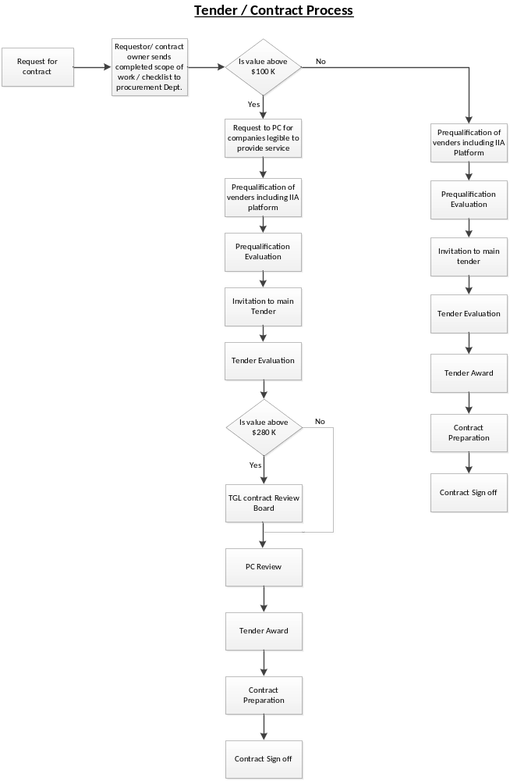

tender special notes
As part of the tender submission by vendor, the following need to be satisfied:

- Tender proposals will be presented in hard copy format, in sealed envelope. Either delivered by hand or couriered directly

- Tender proposals will be clearly marked “Confidential” and must highlighting the following:

- Subject: TENDER FOR SUPPLY LUBRICANTS
- For “the attention of: MPSG -Tender Bid Evaluation team
- Be delivered to: Modec Production Services Ghana JV Ltd, Plot No.71, Off George Walker Bush Highway, North Dzorwulu, Accra

- Vendor will complete – if not completed to date, all the required Vendor vetting and HSEQ prequalification forms related for scope of works.
The applicable forms below will be supplied to vendor.

Vendor Checklist: | Received and or submitted previously
0005-ACC60-15F1-0206 VENDOR VETTING WORKSHEET
0005-ACC60-15F1-0203 LEVEL 1 – VENDOR DUE DILIGENCE QUESTIONNAIRE
0005-ACC60-15F1-0205 LEVEL 2 – VENDOR DUE DILIGENCE QUESTIONNAIRE
0005-ACC60-15SM-0501 SUBCONTRACTOR HSE MANAGEMENT PROCEDURE
0005-ACC60-15F1-1302 MODEC GHANA CONFIDENTIALITY AGREEMENT

- Tender proposals need to be submitted by 17:00 GMT on Thursday, 6th December, 2018
when the Tendering process is then closed.

BID CLARIFICATION MEETINGS AND PHONE CONFERENCES
The purpose of bid clarification meetings and phone conferences is to ascertain that the Bidder fully understands the commercial and technical scope of work and all specification requirements and to ensure that the Bidders` proposal fully complies in all aspects.

MPSG shall arrange all bid clarification meetings and phone conferences. Participation in such meetings and phone conferences shall include the HOD, Procurement department and Bidders. Representatives of other disciplines e.g. HSEQ, QA/QC may be included as required.

Where any enquiries are required to assist in preparation of vendor proposal, they will be addressed by email to nominated specialist for the particular tender in the following areas:
A. Technical / Operational
B. Commercial
C. Contract/legal

TENDER EVALUATIONS & award
The Tender Committee shall recommend the selected Bidder by reporting through the Bid Evaluation Form, after a final review.
The MPSG Tender committee will then be responsible for:
- Receipt of sealed tenders and planning evaluation.
- Reviewing and evaluating submitted bids from Vendors against set criteria, checklists, following procedures applicable and due process and recording this.
- Recommending the selected Bidder to the MPSG In Country Manager.

NOTIFICATION OF AWARD
When the award recommendation has been approved, a formal letter of notification of award (Offer letter) shall be sent out immediately to the successful bidder. The successful bidder shall return a formal written letter of acceptance.

applicable modec references for information
0005-ACC60-15F1-0206 | VENDOR VETTING WORKSHEET
0005-ACC60-15F1-0203 | LEVEL 1 – VENDOR DUE DILIGENCE QUESTIONNAIRE
0005-ACC60-15F1-0205 | LEVEL 2 – VENDOR DUE DILIGENCE QUESTIONNAIRE
0005-ACC60-15SM-0205 | THIRD PARTY INTERMEDIARY AND BUSINESS PARTNER POLICY
0005-ACC60-15F1-0209 | THIRD PARTY INTERMEDIARY QUESTIONNAIRE
0005-ACC60-15F1-0210 | BUSINESS SPONSOR QUESTIONAIRE 3RD PARTY
0005-ACC60-15F1-0211 | ANTI-CORRUPTION COMPLIANCE CERTIFICATION(3RD PARTY)
0005-ACC60-15F1-0212 | BUSINESS PARTNER QUESTIONAIRE
0005-ACC60-15F1-0213 | BUSINESS SPONSOR QUESTIONAIRE (BUS.PARTNER)
0005-ACC60-15F1-0214 | ANTI-CORRUPTION COMPLIANCE CERTIFICATION (BUS.PARTNER)
0005-ACC60-15SM-0208 | WORKPLACE DRUGS & ALCOHOL POLICY
0005-ACC60-15SM-1110 | OCCUPATIONAL HEALTH MANAGEMENT
0005-ACC60-15SM-0501 | SUBCONTRACTOR HSE MANAGEMENT PROCEDURE
0005-ACC60-15F1-1302 | MODEC GHANA CONFIDENTIALITY AGREEMENT

for TENDER PREPARATIONS
- Contractor shall, preferably, be a Ghanaian registered indigenous company as per Petroleum (Local Content and Local Participation) Regulations 2013.

- Contractor shall have valid Ghana Petroleum Commission Certificate for operation in upstream oil and gas sector.

SCOPE OF SUPPLIES

SEE ATTACHED EXCEL SPREADSHEET

Deliverables
The quantities above are annual consumption and the successful vendor will be given a standing order/ framework agreement for delivery as and when required and at the agreed quoted price. Invoice shall be submitted upon each delivery, for payment to be effected with 30 days from receipt of Invoice.

Additional information required:

- Contractor shall demonstrate capacity and capability for execution of scope of supply required.
- Contractor shall provide separate commercial schedule and include prices. The currency of the tender shall be Ghana Cedis. However, contractor who wishes to quote and invoice in foreign currency shall provide Bank of Ghana approval to do so.

- Contractor shall provide audited company financial statements for the last three years.

Submission of Tender
Interested Companies should send their duly completed submissions electronically or via email on or before the close of day, Thursday, 6th December, 2018 to the address below. Late submissions will not be accepted.

Address for submissions
MODEC Production Services Ghana JV Limited
Plot No.71, Off George Bush Highway,
North Dzorwulu, Accra
Tel: +233(0)302215250
Email: Alfred.Wilson@modec.com
Cc: John.Addei@modec.com

